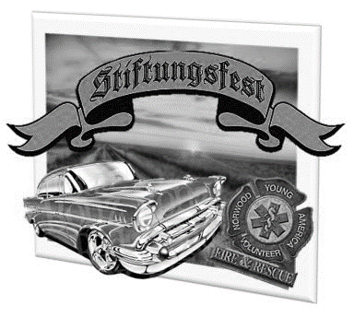
18TH ANNUAL STIFTUNGSFEST CLASSIC CAR, TRUCK, and BIKE SHOW
SATURDAY AUGUST 24TH, 2019
PRE REGISTER BY AUG 1ST
$10.00 PER CAR
NON-REFUNDABLE

Name________________________
Address______________________
City______________________ State______ Zip Code____________
E-Mail_______________________
Vehicle ________________ Model_________ ______ Year________
LIABILITY NOTICE: In acceptance of the right to participate in the car show and cruise entrants and their guest, by signing this form, release and discharge the Stiftungsfest event, members, city of NYA, the car show committee and its members from any and all known damages, injuries, judgments, and/or claims for any causes whatsoever that may be suffered to their person or property. The “committee” reserves the right to remove entrants on the basis of objectionable behavior.
SIGNATURE OF ENTRANT____________________________Date_______________
CHECKS PAYABLE TO: Stiftungsfest Car Show AT GATE: Please return at registration table
MAIL TO: Lisa Valiant 312 W Hwy 212 Ste B Norwood Young America, MN 55368 to get your window card, car#, and dash plaques

